Instacart Data Analysis

Fadwa Elhor

Business Analytics

Table of Contenants

**I.** **Introduction** 2

**II.** **Customer habits** 2

1. When do people order? 2

a) What day of week are most purchases made? 2

b) What time of day are most purchases made? 2

c) How long do people wait before placing another order for items? 3

2. What do people order? 4

a) What are the best sellers? 4

b) What are the most frequently re-ordered items? 4

c) Organic VS no organic Food 5

**III.** **Strategy and recommendations** 6

**IV.** **Conclusion** 6

# **Introduction**

The mission of Instacart is to ensure a customer satisfaction achieved by anticipating and identifying customer needs and providing products and services to satisfy them.

Data analysis for Instacart customer shopping behavior,will help to develop a strategy for shopping plans.

# **Customer habits**

Basing on Instacart customer shopping dataset, we can get a better idea related to users shopping behavior.

## When do people order?

First question to answer related to costumer’s behavior is: What days of the week are most purchases made?

### What day of week are most purchases made?

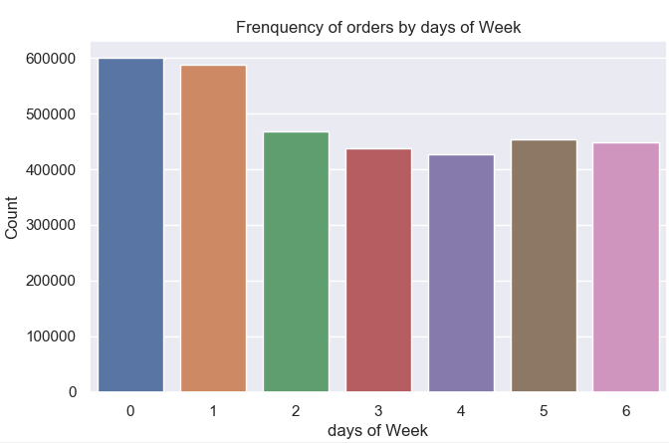

Figure 1 : Frequency of purchases basing on week days

As we can see, the most purchases are done in Sunday and Monday.

### What time of day are most purchases made?

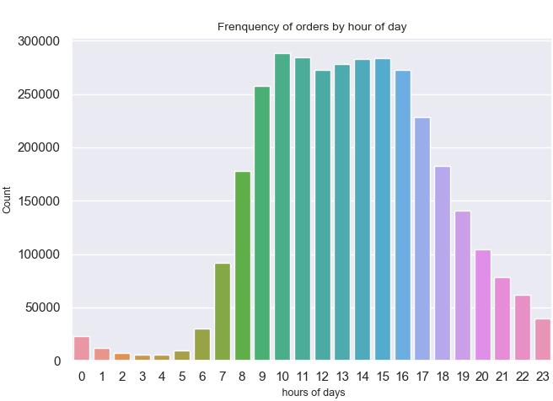

Figure 2 : Frequency of purchases basing on week days

The firs observation we can make, is that most shopping orders are made Sunday and Monday between 9 am and 5pm.

### How long do people wait before placing another order for items?

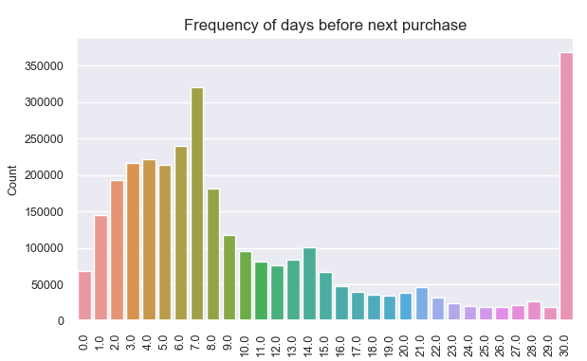

Figure 3 : Frequency of days before people do another purchase.

It’s clear that most majority of customers do their next purchase after 30 days, and other after 7 days.

After this analysis, we start have an idea about the customers behavior. The timing where customers made their order via Insacart. App can be helpful to target users with precise promotion.

## What do people order?

In order to have more details about the customers shopping behavior, we will analyze what they buy.

### What are the best sellers?

Using the data related to the product ordered from Instacart, we will display only the 20 most purchased.

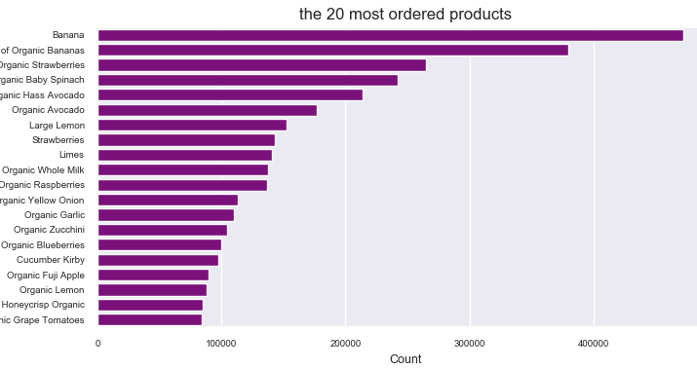

Figure 4: The 20 most ordered products from Instacart

It’s evident that fruit and vegetables are the most purchased products

### What are the most frequently re-ordered items?

Before figure out the most re-ordered product, we will check out the ratio of reordered product vs ordered.

On average, 59% of the product ordered are reordered

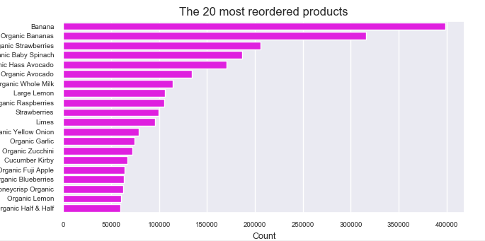

Figure 5: The 20 most reordered products from Instacart

We notice, that the fresh fruits and fresh vegetables are more likely to be reordered again and they still the most purchased products.

### Organic VS no organic Food

Do customers prefer organic food? The figure below will give us the answer.

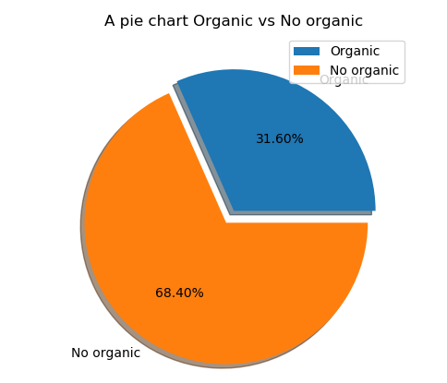

Figure 6 : Partition of Organic vs no organic purchased products

The organic products are in demand by 31.6% over all.

# **Strategy and recommendations**

Basing on this data analysis, we will come with some recommendations. In fact, we can use market product expansion grid to develop a new strategy plan.

Those are some ideas:

* **Market penetration:**
  + users who make 4 orders will gate a 5% discount for the 5th reorder
  + The organic products are in expansion, around 32% of product ordered are organic, a good promotion will encourage more and more users to consume a healthy food
  + Users make most order in Sunday and Monday. Update recipes on Friday to allow users to get the necessary food to prepare their dishes.
* **Market development:** make a focus in the teenager’s nutritive plan
* **Product development:** promote dishes that have already been prepared and that meet special needs according to the diet followed.
* **Diversification:** people who suffer from health problems and who need a special diet should not be neglected (exp: diabetic people), dishes that will be prepared to fit their need, will be a way to reach and retain a new market segment.

# **Conclusion**

The Busines Analytics represent a gold mine of information to exploit and bring out ideas to target new customers and increasing customer life cycle.